**Embedded Systems learning journal**

**Task 1:**  Familiarisation

Within this section of task 1, we will be looking at the Arduino environment, and the correct methods to utilise and set up our working environment for this module. This first task is made up of eleven requirements which will help familiarise us with the Arduino equipment and the software used.

**Requitement 1:** Obtain an Arduino Mega or Uno Board and connect to a PC. [**09.10.2020**]

Within our first week of starting the CI514 module (Embedded Systems) I took it upon myself to go and collect my Arduino board from the help desk which can be found on level 4 of the Cockcroft building at Moulsecomb. The process was straight forward and within seconds I had my hands on the Arduino kit I will be using for this semester. The kit that I received included the following below.

* **1x** Arduino board Mega 2560
* **6x** LED’s of different colours (Green, Amber and Red).
* **1x** USB type A to type B.
* **6x** Pin connectors
* **1x** Breadboard

**What is an Arduino board?**

An Arduino board are read input device that takes information given by the user / machine to perform tasks, instructions, and functions physically. An example can be controlling a sequence of lights to illuminate in a certain order.

The Arduino board we were given had the following specs in terms of performance.

* **CPU** – 8-bit Atmel AVR (16MHz).
* **Flash** – 32Kbytes.
* **RAM** – 2kBytes.
* **EEPROM** – 1kBytes.
* **Input** – Analog / Digtial, PWM, Serial, I2C and SPI.

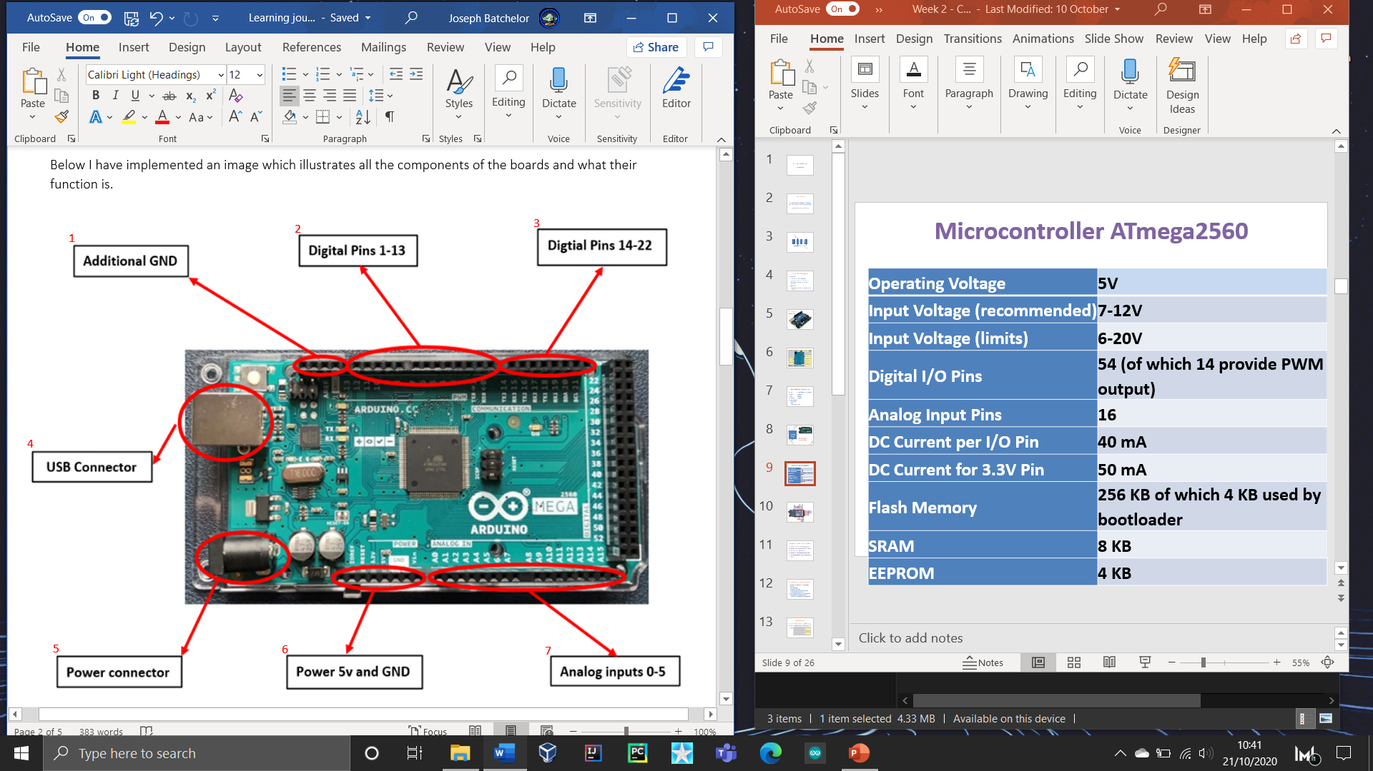Below I have implemented an image which illustrates all the components of the board and what their function is.

|  |  |  |
| --- | --- | --- |
|  | **Component** | **Function** |
| **1** | Additional GND | These pins are used to ground the circuit, this is where the voltage is 0. Which makes it the negative terminal protecting items from overloading. |
| **2** | Digital Pins 1-13 | These are pins that can be configured to preform input actions or to send actions as outputs. This is how we can communicate with the Arduino to do input tasks. |
| **3** | Digital Pins 14-22 |
| **4** | USB Connector | This used to power and send complied code to the Arduino board from the machine. Essentially acting as a bridge of communications both ways. |
| **5** | Power connector | This just provides power to the board with no bridge of communication. |
| **6** | Power 5v and GND | This allows you to draw 5-volt power from the Arduino board to be used as output power. |
| **7** | Analog inputs 0-5 | This allows you to convert a voltage into a digital value, which can be stored and processed by the computer. |

**What is a breadboard?**

A breadboard is a tool that has hundreds of tiny indentations, designed to hold pin connectors such as LED’S or power connectors. The premise is that when using a breadboard, it is an easy way to insert pins when needed. It is also designed in such a way that reduces the amount components needed for function.

Below is a photo which describes some unique features of the board.

The breadboard is designed in a way where it uses two types of power transfer /connections which are vertical and horizontal.

The idea behind this is that you can use one GND or digital pin in a horizontal line (**the red line**) to transfer power or to communicate throughout the board. This will allow you to reduce the number of connectors used as you can use one pin for the desired function.

The vertical lines (**the purple line**) transfers power / communicates vertically which allows for multiple components to have their own lane, essentially this allows for multiple / different digital pins to be used at once and to be assigned separately.

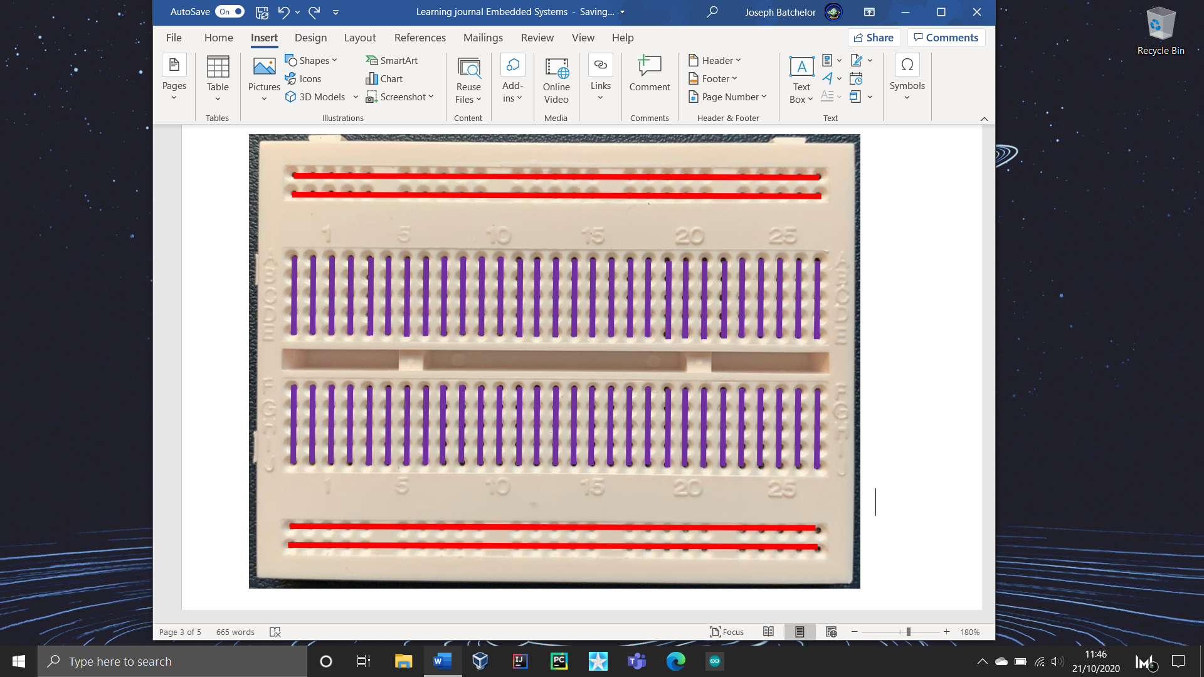

**Red Lines –** powers / transfers in a horizontal line.

**Purple Lines –** Powers / transfers in a vertical line.

**Requitement 2:** From the computing programmes select Arduino program. [**09.10.2020**]

This next requirement is setting up our Arduino program which will be our working environment. This is a simple process as you can download the program from the internet or from the Microsoft store.

The Arduino IDE we will be using was developed by the creators of Arduino (Arduino LLC). The reason we are using this developer tool is because of its easy-to-use software and hardware, along its open-source platform this allows for a variety of examples and templates to be accessed from the website.

There are two ways to download the IDE which can be seen below. Both methods work however, using the microsfot store is a lot quicker. Simply navigating to the app and searching Arduino will give you the software to download. For the other method simply navigate to the site using the link provided [***https://www.arduino.cc/en/Main/Software***](https://www.arduino.cc/en/Main/Software), this will take you to the software area, scroll down where you are able to download the latest version. Below is what you should be presented with.

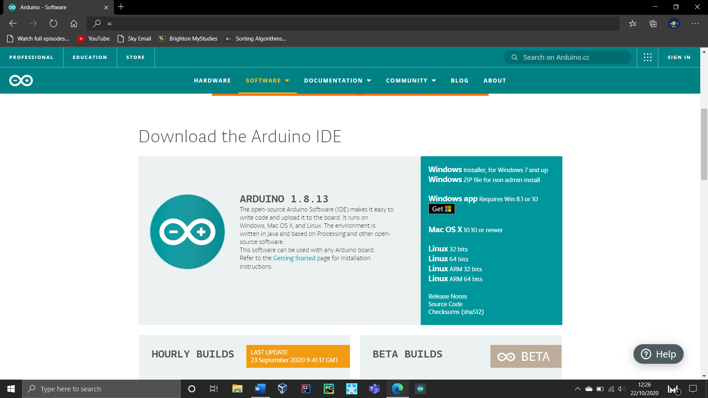

Select one of the following for your OS

**Requitement 3:** Activate the Arduino environment. [**09.10.2020**]

This step is simply installing the software and then activating it once completed. This a straightforward task as once you downloaded the software, it will instantly download without providing a class path. Making it easy to set up and use.

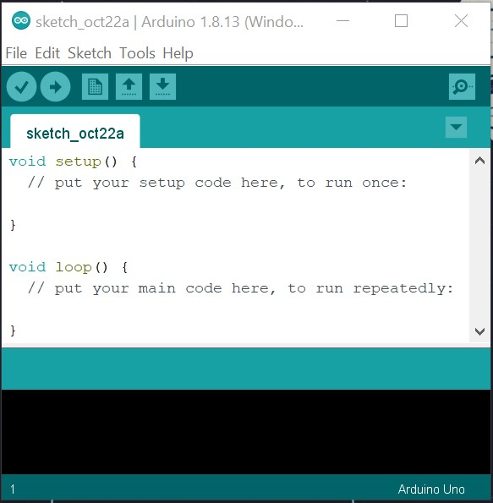On the first time of opening the software you will be presented with a basic structure of code; this will display an empty setup method and an empty loop method, as seen to the right.

The Arduino software will open to a template, that will provide two empty methods. You can alter / use these for quick easy use.

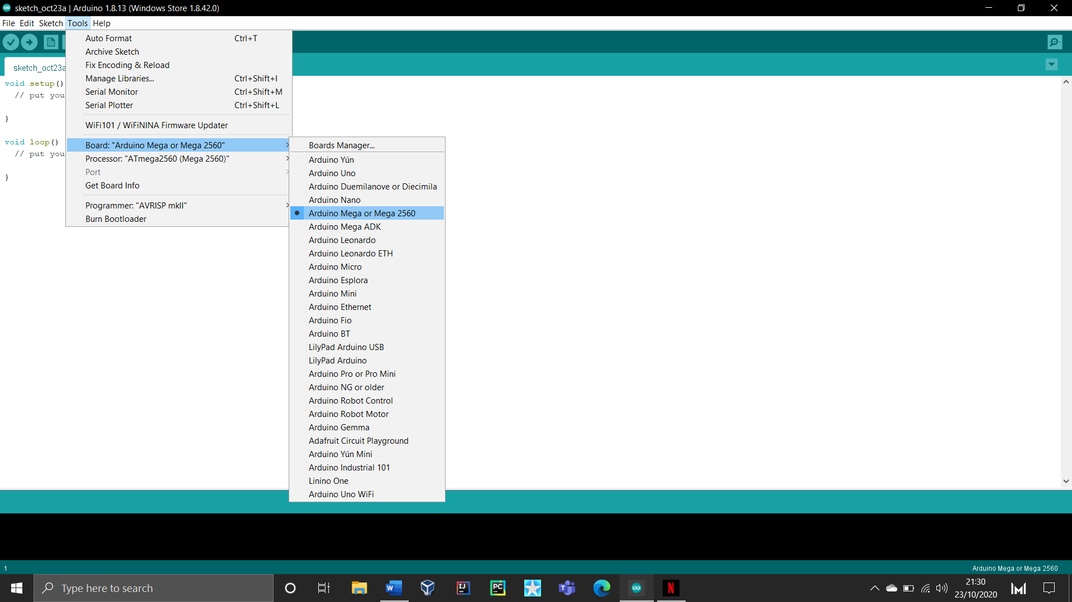**Requitement 4:** From the drop menu select the Arduino board type from the Tools drop down Menu. (The Board used is Arduino Mega). [**09.10.2020**]

This task simply requires us to set up our Arduino board in-order for it to work with the IDE, this is because different Arduino board types have different specifications which usually requires different communications options such as the arrangement of the digital pins. As you can see in the photo to the left to simply set up the IDE for the use of our board, we had to hover over tools option and then again over board. This will present you with a selection of boards that will be compatible with the IDE. Simply find and select your board to complete this task.

**Requitement 5:** From the same drop-down Menu select the COM port that communicates with the board. [**09.10.2020**]

The next task is to set up the port for our Arduino board. The reason we are doing this is because this allows us to establish communication from our board to our machine. To do this simply hover over the tools option and locate the port option, again hover over port, and select COM1. All Arduino boards have at least one serial port and the point of a serial port is to allow communication between the digital pins on our board to our machine.

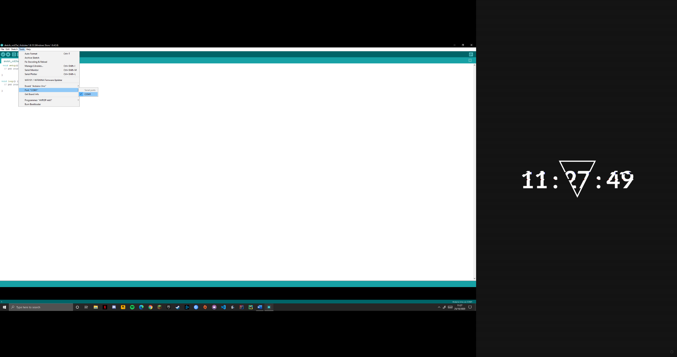

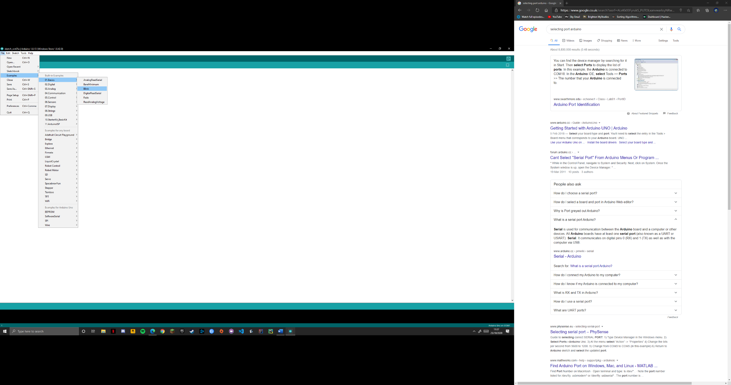**Requitement 6:** From File drop menu choose the “Example” and choose the “Digital” and choose the programme “Blink”. [**09.10.2020**]

The next task is to use an example known as blink. An interesting and useful feature to the Arduino IDE is that it can provide examples that already contain premade classes and methods. All it requires is a slight alteration for it work with your board. Below is an image of the code it provides to you.

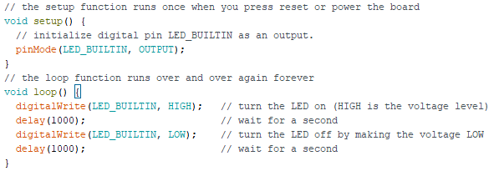

**Requitement 7:** Upload the program and go through compilation process. [**09.10.2020**]

As like most IDE’s, Arduino’s software shares a similar process to compiling code. Once your code has been completed simply press the compile button which is shaped as a tick this can be found within the top left section. This will uncover any errors that will need to be dealt with, it is important that you recertify these problems before uploading.



Compiler

**Requitement 8:** Upload the program and run it on the Arduino Board. [**09.10.2020**]

Unlike most IDE’S you do not need to upload your code, this process is important as this essentially sends the code from your machine to your board for it to function. The way we do this is once your code is sorted and complied the next step is to upload your code to your board, in-order for this to happen the board will need to be connected via USB. Simply click the arrow button next to the compile tick button and wait for your code to be sent to the board. With seconds your code should be functioning as intended.



Uploader

**Requitement 9:** You should see an LED Blinking on the Board. [**09.10.2020**]

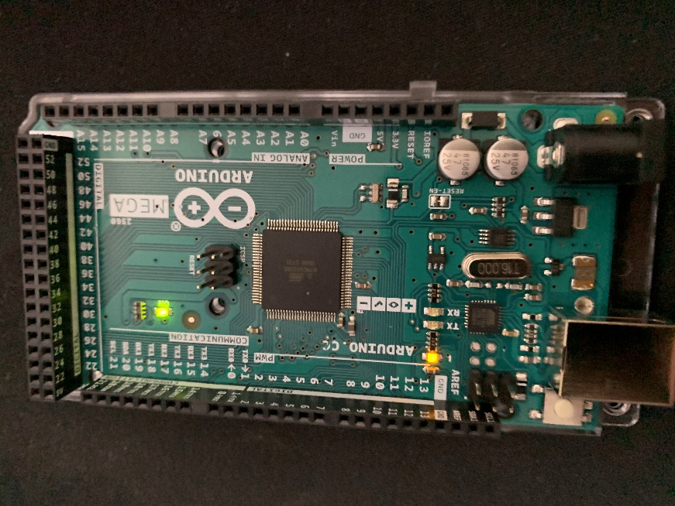

This task is just to look at the Arduino board and see how it functions when sending code to the board.

The green LED indicates that the Arduino board is receiving power and is functioning.

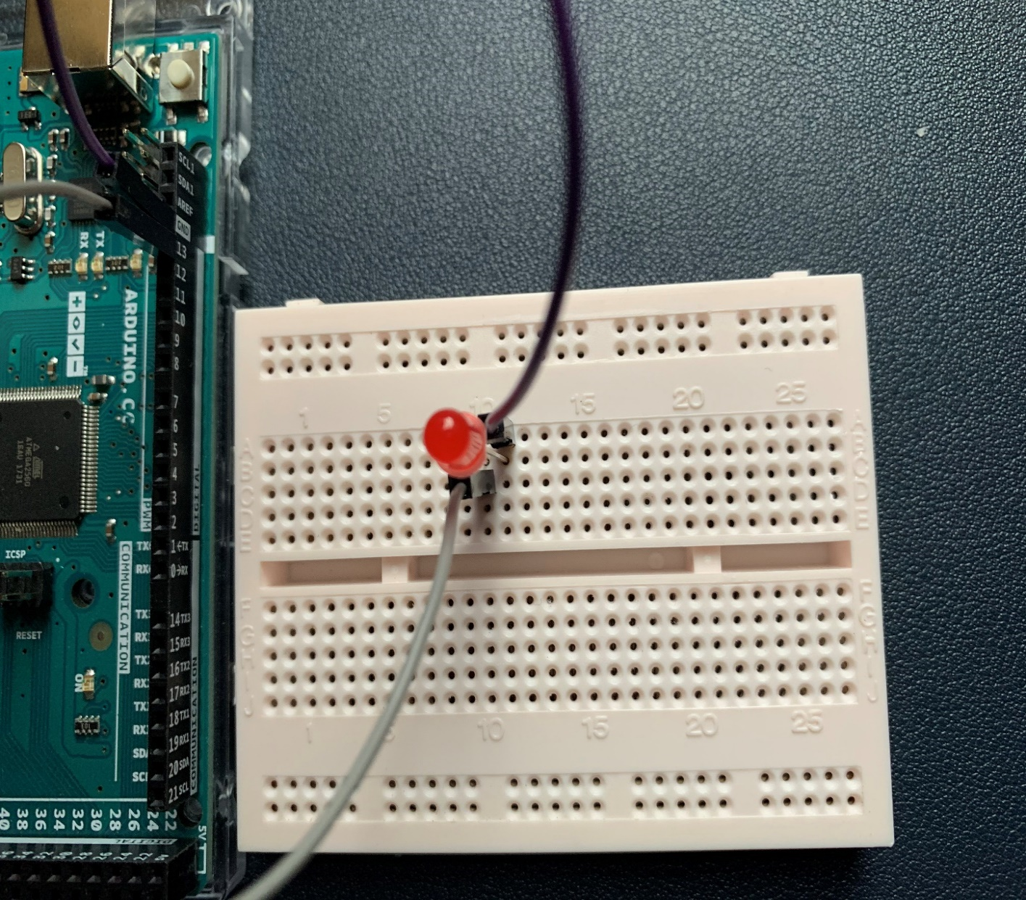**Requitement 10:** You can also use a Bread board and link it up with the board and use an LED to see it Flashing. [**09.10.2020**]

Using a breadboard which was given to us within our kit, we can use to pin connectors and an LED to make it flash. With a pin connector in the ground slot and one in digital pin 13, I can give each one its own lane as seen on the breadboard it is important that each gets its own lane otherwise it will not work. Next is putting the LED in both lanes making sure that the long leg is next to the pin connector that is connected to the digital pin 13. Then simply run the program.

Grounded horizontal lane

Digtial pin 13 connector slots

Power horizontal lane

Grounded connector slot

**Requitement 11:** Increase the number of lights to three and switch them serially. You need to modify the program to do this. [**09.10.2020**]

This task challenged us to increase the number of lights from one to three, as well as programmed them to flash within a sequence (one at a time). First step is to add the additional LED’s to the breadboard, because each LED will perform different functions or the same function however, at a different time each LED will need to be given a separate Digital pin. This will allow us to allocate the correct code for each LED as they will be function independently from one another.

To the left is an image of the correct setup for the LEDS in the bread board. You can see that the Blue, White and purple connectors are all sharing the same vertical lane this is so that the GND (ground) can be connected for each LED by using one lane. With the rest of the pin connectors each have been being given a separate digital pin that will be used within the code as well as to provides power to the LED.

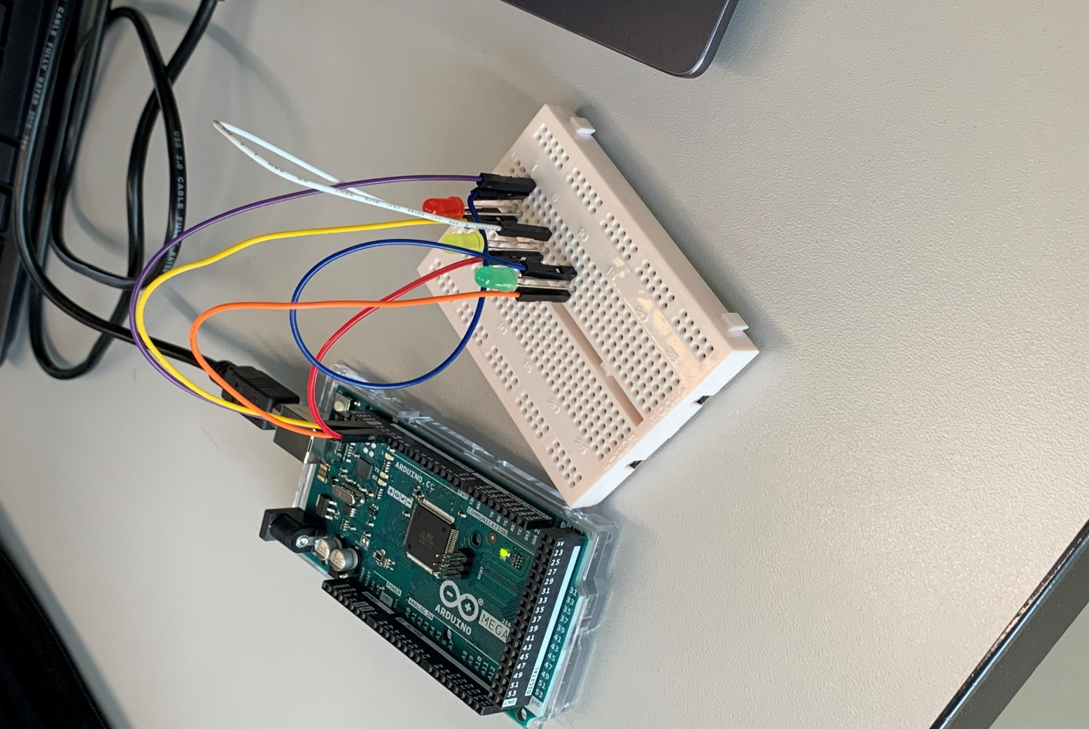

Below I have implemented a photo of the code I had made to get the LEDS to flash within a sequence one after the other. I have pointed out key areas which are key for each block and overall code to function correctly.

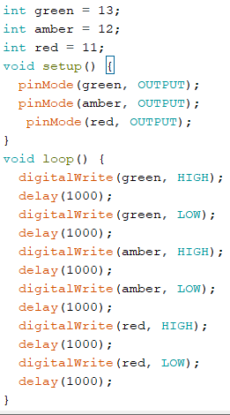

To start off I gave each digtial a variable corresponding to its colour. This isnt necessary however, it makes it easy to remember which pin is what colour. Alternatively, you can just use the digital pin value instead of assigning it to a variable.

The setup function runs once when you press reset or power the board. Within this function I am initializing the digital pins green, amber and red as an output. Which means that I am using pins 13, 12and 11. I am also using the term output which means that machine is telling the board to do something, if it were input this means that the board would give information or a function to the machine .

This function is a loop. What this means unless specified a condition, this function will constantly loop through every bit of code until a condition is given or met. In my code I have not given a condition which means it will perform each conde with the block once before repeating.

These statements are what controls the LED’s to perform a function. The example we are looking at will be controlling the red LED which is pin 11. By using the keyword digital write this tells the Arduino board to do something in this case we set pin 11 to high which means on or 5 volts. The keyword delay is telling the code to sleep in this case for 1 second. This will pause the initialization of code for one second which should keep the light on for 1 second then repeating the same statements but with low. The term low means off or 0 volts, this is what turns the LED off and again using delay to keep it off for one second. So, the code should turn each LED starting with green on for one second then off for one second before moving to the next LED or digital pin and then repeating.

**Task 2:**  Traffic light simulation Using C language

This section requires us to create different simulations using the language C.

**Task 1:** Create a single traffic light sequence using the language C and the Arduino board.

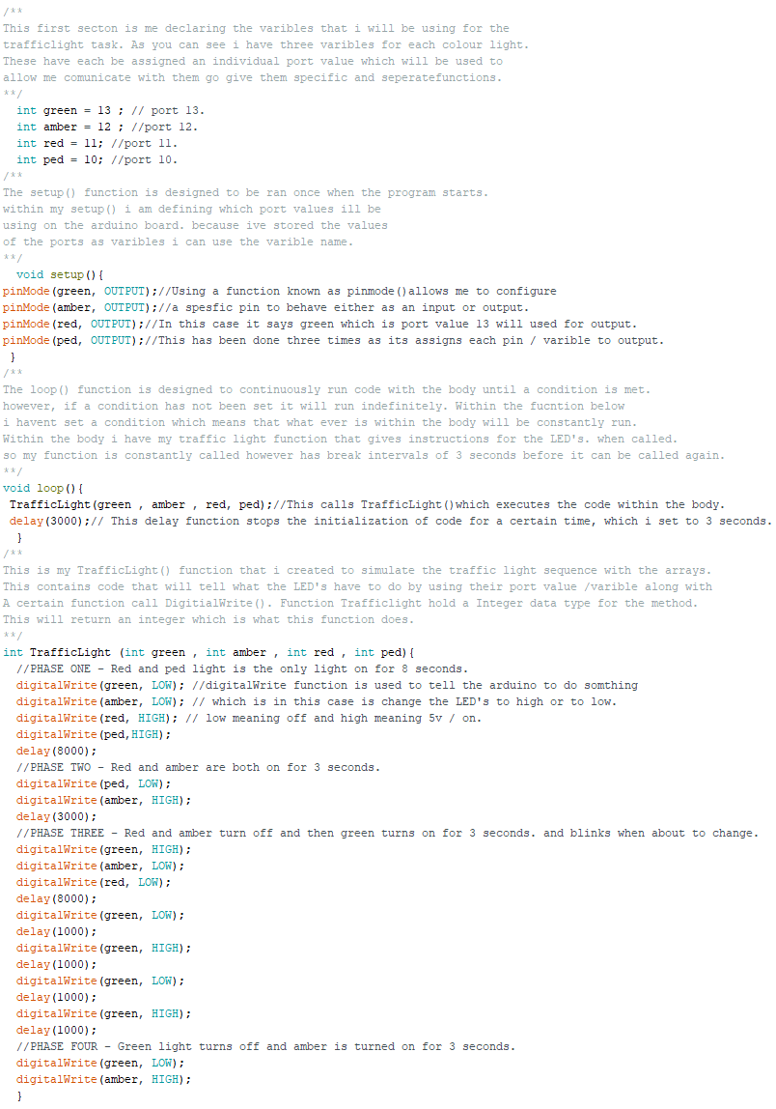This was as easy task to do as it only consisted of using only two functions and simple statements. Below you can see my code which explains and displays how each part works.

**Task 2:** Modify the developed algorithm and produce a new flowchart to provide a solution for the operation of a junction with two four-phase traffic lights and Implement the modified algorithm and a program in “C” to show its operation.

**Task 3:** Modify the flowchart for the Junction and provide a new flowchart which provides a pedestrian crossing by using a single green LED (or both RED and green if you prefer) and Write a “C” program to implement the flowchart.

Both task 2 & 3, were to improve and implement my code so that it could be applied to a junction scenario. Additionally, it required us to create a flowchart which illustrated our code. Below I have the created a flowchart and implemented code that covers both the needs and aspects of task 2 &3.

Starting with the flowchart I designed it in pseudo code which is a simple form of righting code. The structure of the flow chart still illustrates how the code is initialised and the decisions it makes. There are three main functions in my code which are the Loop function, trafficlightSet1 and trafficlightSet2.

Traffic light set one and two both share the same layout however both have different port values for each LED. In total there should be 8 LED’s used for both the traffic lights and the pedestrians’ light.

Below is the flowchart of the functions Loop. This essentially is designed to constantly run functions within its body. Additionally, it uses a for loop which helps decided which traffic light set needs to run.

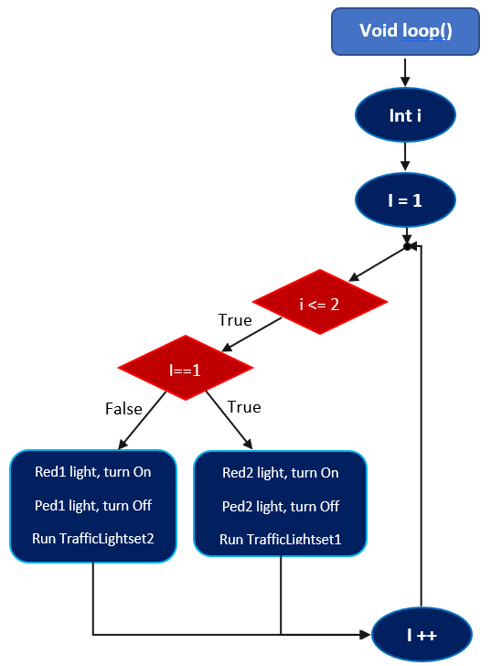

Starting off I Initialized the variable i as an integer and then setting its value to be equalled 1. This will be used within a basic for loop.

The next part in red is the for loop which says that i can be equalled or less than 2. This means that i can only be 1 or 2 and nothing greater. This statement will be used to switch between the two functions.

If the values true, then it will move down to the if statement which is if i am is equalled to one then call TrafficLightset1 function and preform the sequence. This will only run if i = 1, else it will switch and call Traffic Light set 2 function.

While each function is called it will also set the opposite sets red and ped light on. This is to simulate that while the other traffic light is red is will allow pedestrians to cross.

Once the first condition has been executed it will increment i++ by one. Once i is equalled to 2 then the loop will stop, and the function loop will start again setting value i back to zero.

For loop

If statement

The next flow chart demonstrates how both traffic light functions work. Primarily these functions both use a for loop and a switch statement. The switch statement has four different cases where each case acts as a different light phase. The for loop simply alternates through the switch running each code from case 1 to 4.

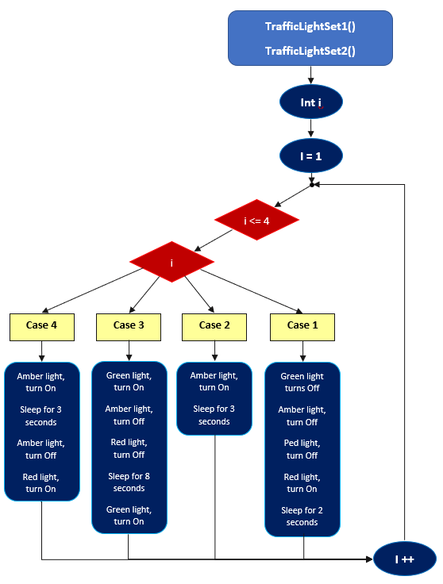

This begins with initializing an integer which is i. I declare variable i to be equalled to 1.

This is then used within a For loop which can be seen in red. The for loop states that i is less than 4, essentially this will perform four loops.

The reason four is because we have four cases within the switch statement one for each phase.

As i is looping the switch statement is taking in the value of i and finding which case i is equalled to. For example, if i is equalled to 1 then case one will be called.

Each case has code nested within them that corresponds to each phase of the traffic light system.

Once the case has done executing the code, it then increments I++ by one within the loop.

What this will do is call the case 2 as i is now equalled to 2. This is done up to four.

Once each case has been called and i is equalled to 4. This stops the function until called again.

When called again the value of i will be set back to 1 to repeat the same sequence again.

For loop

Switch statement

Within this section I will be discussing the traffic light junction code implementation. As part of task 2 we were required to create a traffic light sequence within a junction. This meant that we had to create two sets of lights that alternated between each other to allow cars across.

Additionally, task 3 required us to further improve the code and implement a pedestrian light to indicate when it was safe to cross.

The first section shows off the setup () function which is used to establish which ports we are communicating with. In this piece of code, I have set up eight different types of ports for each LED.

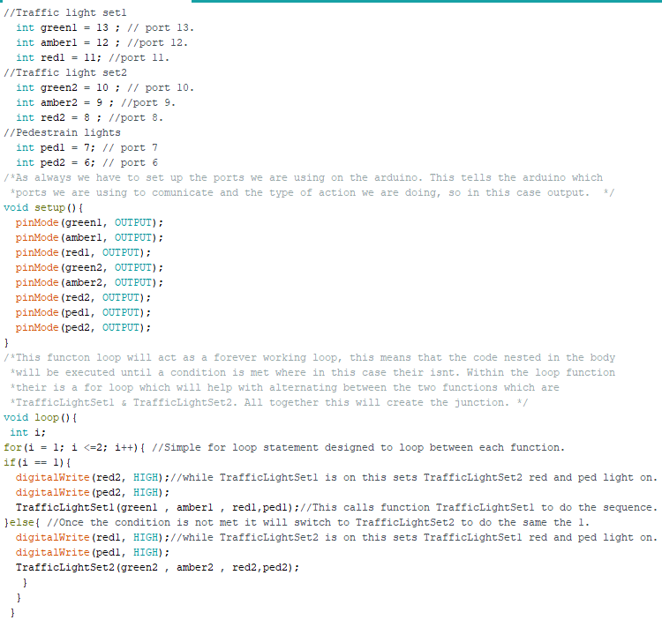The next function is the loop (). This will constantly run the code within the body. The code within the body runs a for loop which will alternate between the traffic light sets.

The next two functions provided the functionality and communication to the Arduino board. Both TrafficLightset 1&2 Preformed the same actions however using different port values. This meant that they were assigned to different LED’s, allowing to fully show case a traffic light system at a junction as well as pedestrians lights.

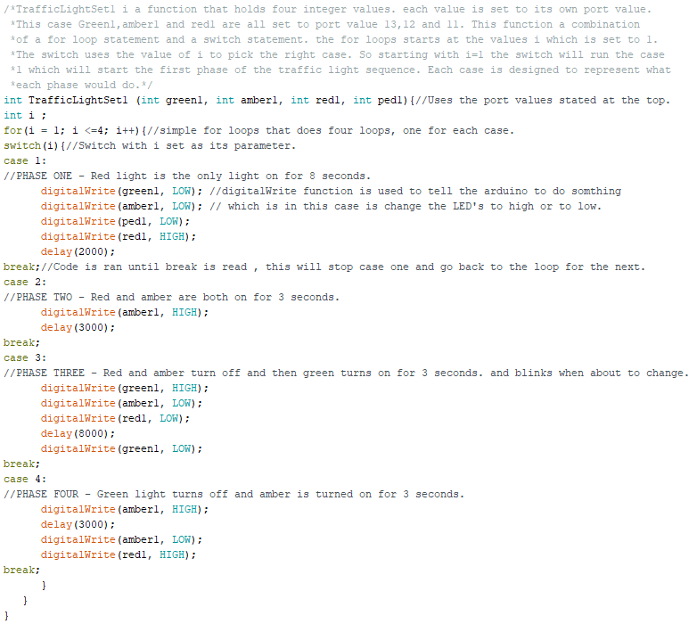The two functions consisted of using a basic for loop and a switch statement. As explained within the flowchart the for loop will alternate between the different cases within the switch statement. This is how I created the four-phase idea where each case would be its own phase.

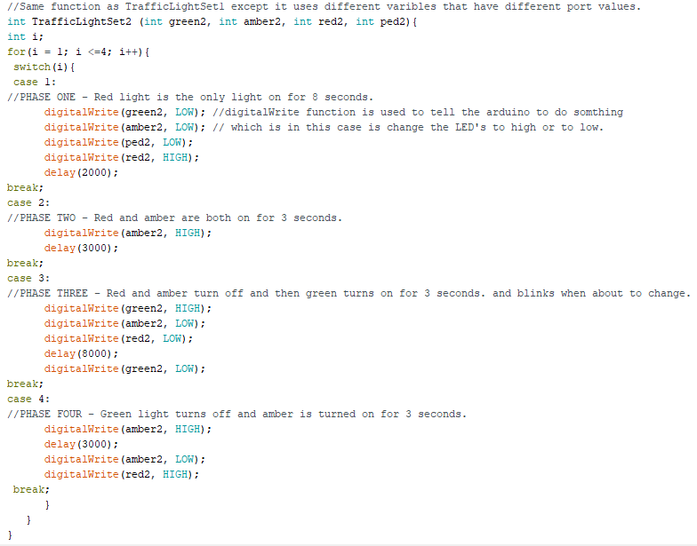

**The Arduino set up**

Below you will see the Arduino set up that allowed me to test and display my code.

In total the task consisted of 8 LEDS’s of various colours and 16 pin connectors. Each Junction has its own vertical track on the bread board.

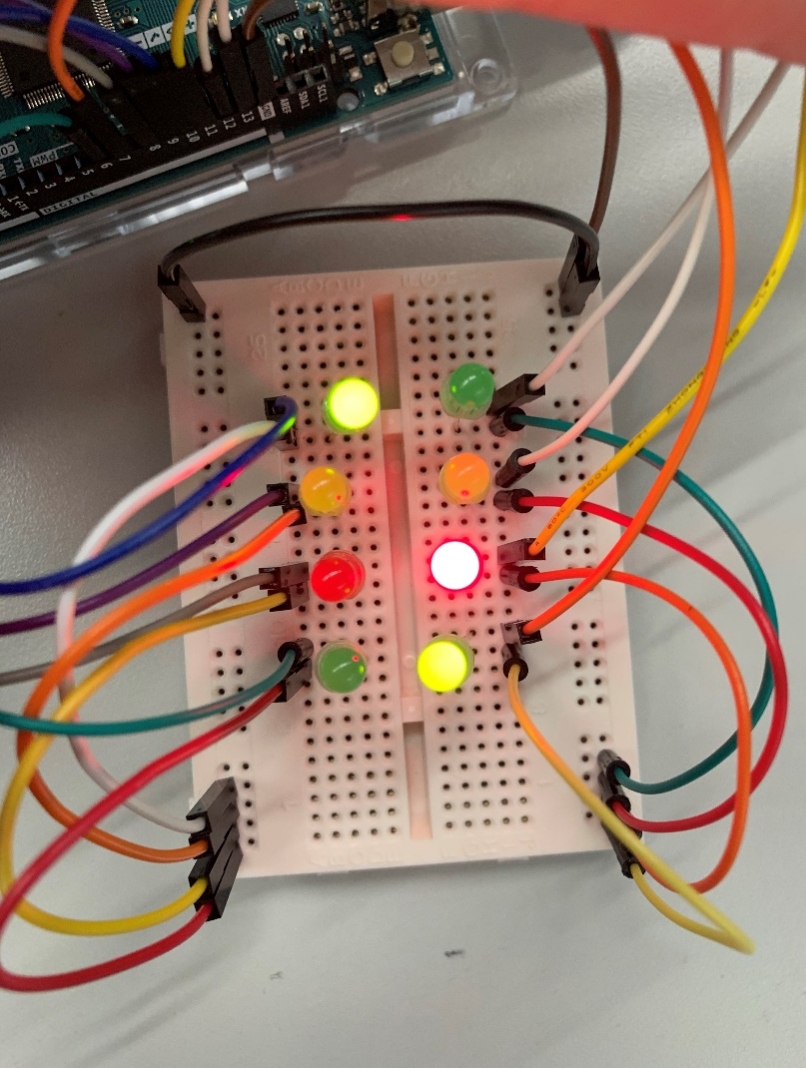

**Traffic Light set 1**

**Traffic Light set 2**

Int Green1

Int amber1

Int red1

Int ped1

Int Green2

Int amber2

Int red2

Int ped2

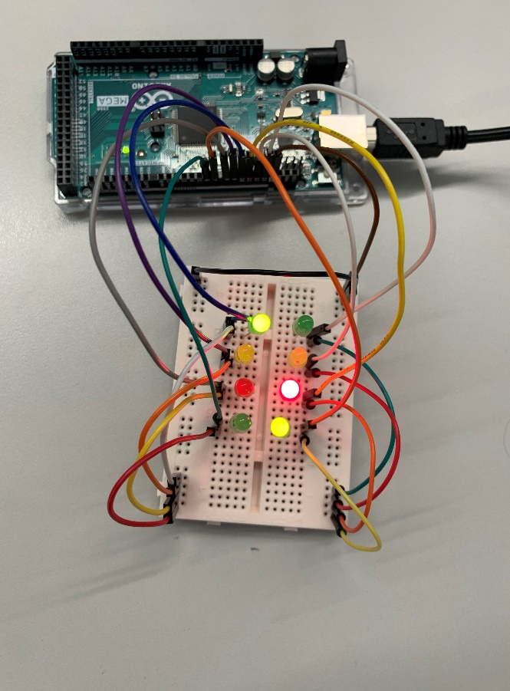Above you can see an image that shows the LED setup of the junction. You can also see that when either junction is green the opposite will be red with the pedestrian light on to allow people to cross. Each set of lights has its own functions as you can see that TrafficLightset 2 has different varibles to that of TrafficLightset 1.

I have listed each variable that both functions use and as you can see there are similar. Each one holds a different port number which allows separate communication and actions to take place.

To the left is another view which incorporates the Arduino board. This shows the connections between the bread board and the Arduino.

Altogether this set up utilises a total of 18 pin connectors. The main problem with this is that it can become too cluttered when working on the bread board. A possible and easy solution is to use a bigger bread board.

**Task 3:**  Sorting algorithm using C language

Within this task we must create a sorting algorithm using the language C. Our task requires us to generate 15 random numbers and to sort them in ascending order, additionally we must display the smallest and largest number in binary using LED’s. We must also create a flowchart to display the functionality within our code.

The idea is to create an array and randomly put 15 elements (integers) within it. Our next step is to make it so when we press a key on the keyboard this will start the sequence of sorting the data as well as displaying useful information. Once that is completed, we will need to display the binary value using 8 LED’s.

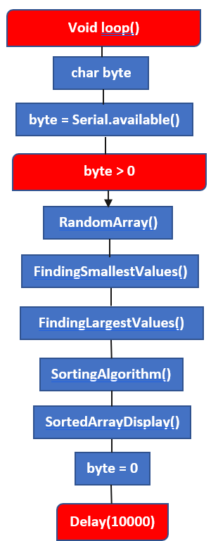Below you will see my flowchart of each of the functions I created and what they do. In total I use six different functions to preform different tasks.

The first flowchart demonstrates the main method within my code. I begin by making a variable called byte with a character data type. I set byte to use the serial.available method which acts as a scanner for the serial monitor. The methods job is to get the number of bytes from the data inputted. It reads the input and converts to a value (which we will be using). The idea is that once any character has been pressed then the algorithm will start.

The first statement within this function is an if statement. If the value of byte which is the character pressed on the keyboard is greater than 0. Then the code will start executing. Essentially any key pressed will be greater than 0, apart from 0.

Within the if statement I called all my functions that will provide preform different tasks. Once each task has been running, it will then set the value of byte to 0. The reason for this is that it will constantly run the code providing new sequences to be sorted.

I included a delay at the end of the function to prevent the data being printed to the screen too quickly.

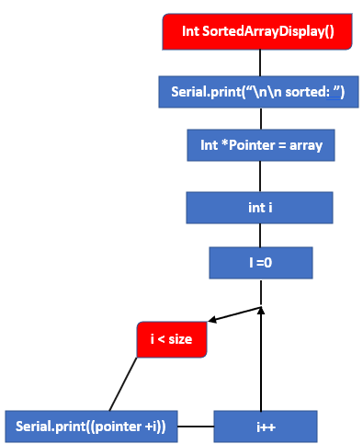

This next flowchart shows off function SortedArrayDisplay(). The first step is printing the word “Sorted” to the serial monitor using the serial.print(), function. This you can see which sequence is which. The next creating a pointer which is equalled to the array.

This will be used to display the finial arrangement of the array. The next step is creating an integer i, which will be used for the for loop.

The pointer is currently equalled to the first element or array [0] of the array. By adding i this will increase the index of the array to use the next element within the array.

The For loop will loop through the size of the array which is 15. This means that it will be able to print all 15 elements within the array. Once the loop has finished so is the function.

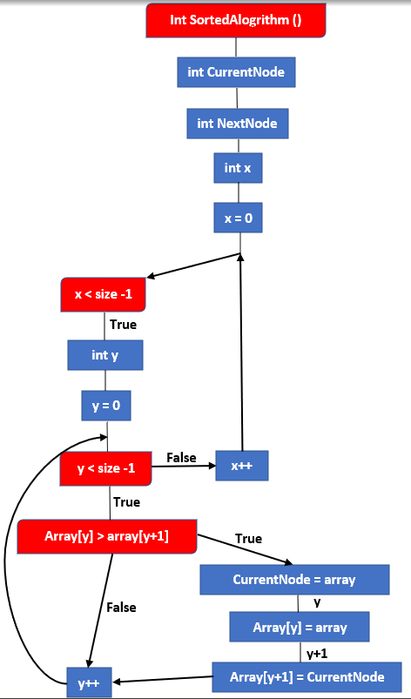

This flowchart to the right displays the function SortedAlgorthim (). The first step within the flow chart is creating three varibles. Two of the varibles are being declared which are Current node and Next node with no value and int x has been initialized as 0. Int x is used for the first for loop. The first loop simply means it will start from 0 and loop through the array size which is 15. Within loop x it will be initializing int y to be used for the second loop. Loop y will be used to make the comparison between the current node and the next node as well as switch them if necessary. Loop y will use an if statement to compare the current node which is array[y] to the next node array[y+1]. If array[y] is greater than array[y+1], then we can switch the elements around else if the statement has not been met then it will do nothing other than increment y. To switch the element, we need to use the varibles elements we created earlier at the start and set their values, so Current node = array[y] and Next Node = array[y+1]. Current node will be our temp, to switch simply set array[y] to Next Node and array[y+1] to Current Node

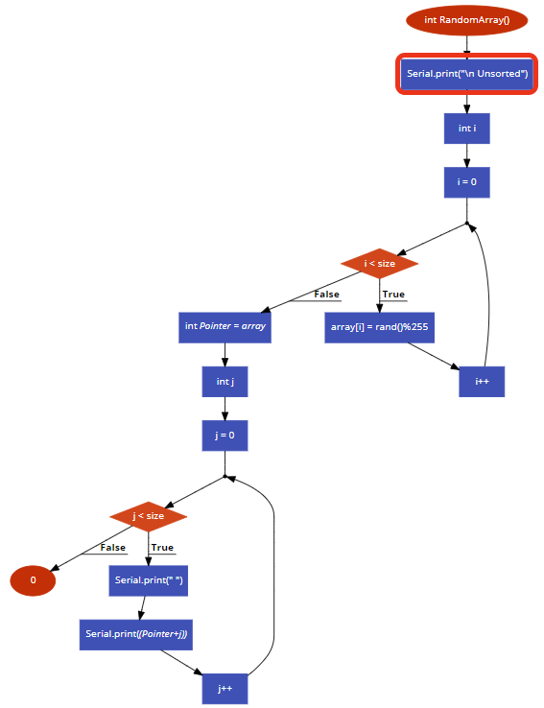

The next flowchart demonstrates the design that RandomArray () uses. To start off with this function the first execution is to print the word “Unsorted:” to the serial monitor. The next step is declaring and initialising i will be set to 0.

The next step is the for loop, using i which means the loop will start at 0, it will loop through the size of the array which is 15. This means 15 times the loop will run the code nested.

The nested code is a function of C which rand(). This function will generate any positive value. By using “Rand() %255” this will give me the remainder which is less than 255. This means that array[i] will be set to the remainder of the random value. The next step is creating a pointer variable that is equalled to the array and a new for loop. The loop will use the pointer to print the elements of the array.

Each value will be printed to the array using serial.Print, Once the loop has completed the function will finish executing the code, return 0.

The final flowchart demonstrates what the functions FindingLargestValues and FindSmallestValues both do. The example below shows the structure of just FindingLargestValues. However, both share the same structures with the only difference being the data and varibles each one uses. However, the function for both is to display information regarding the largest and smallest values within the array, such as smallest value and the position it was found in before it has been sorted. Additionally, both functions will display the 8-bit binary format of both the largest and smallest number within the array.

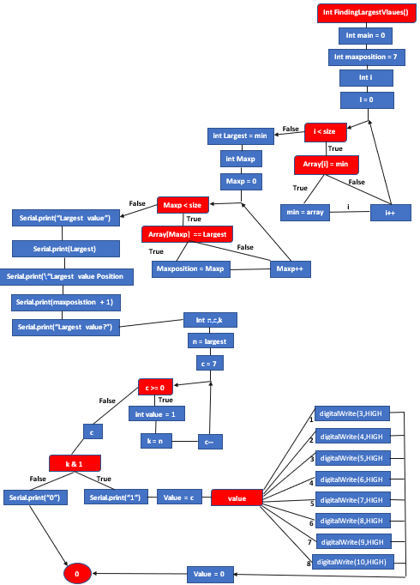

The first step in this flow chart is creating three varibles, these variable are min which will be used to find the largest value in this case, maxposition which will be used to find the position of the largest value with the array, and int a which will be used within the first loop. The next for loop looks for the largest element within the array. The loop will loop through the array comparing the array element to the variable min which is 0. If they are same min will equal that array element, this will keep looping until the largest element has been found within the random sequence. Once found a new variable is made called largest which is equalled to min which is the largest value within the array. Another variable is Maxp, this will be used for the second loop. The second loop works by comparing the variable largest which was found within the previous loop to every element within the array. Once the position has been found it within the loop the index of the loop which will be the current value of Maxp will be set to Maxposition. After the position has been found it then print all the current information found such the largest value as well as the position using a combination of serial.print statements. The next section is to display the binary value of the largest value. This starts off by creating three new integers n, c and k. n is equalled to the largest value and c is set to which is the number bits we need to display value in binary, minus one because it is a loop that is on 0. C will be used for a descending for loop starting from 7 working done to 0, this because it needs to be printed out in reverse as binary works from right to left. In the body of the c loop a new variable called value is made and set to 0 as well as k is now equalled to the largest value. The next step will compare the value of k which will be 1 or 0. The value of k is determined by using the shift operator more is explained later in the journal. However, if k is 1 it will print “1” and the variable value would increment this would allow for the next step which is the switch statement to choose the right case. that has the right LED to turn on. This loop will repeat until all LED’s are on, once on the variable will be set back to 0 and the function is done. However, else if k is “0” it will just print the value ”0” to the screen and will carry on the loop.

Arduino environment resources

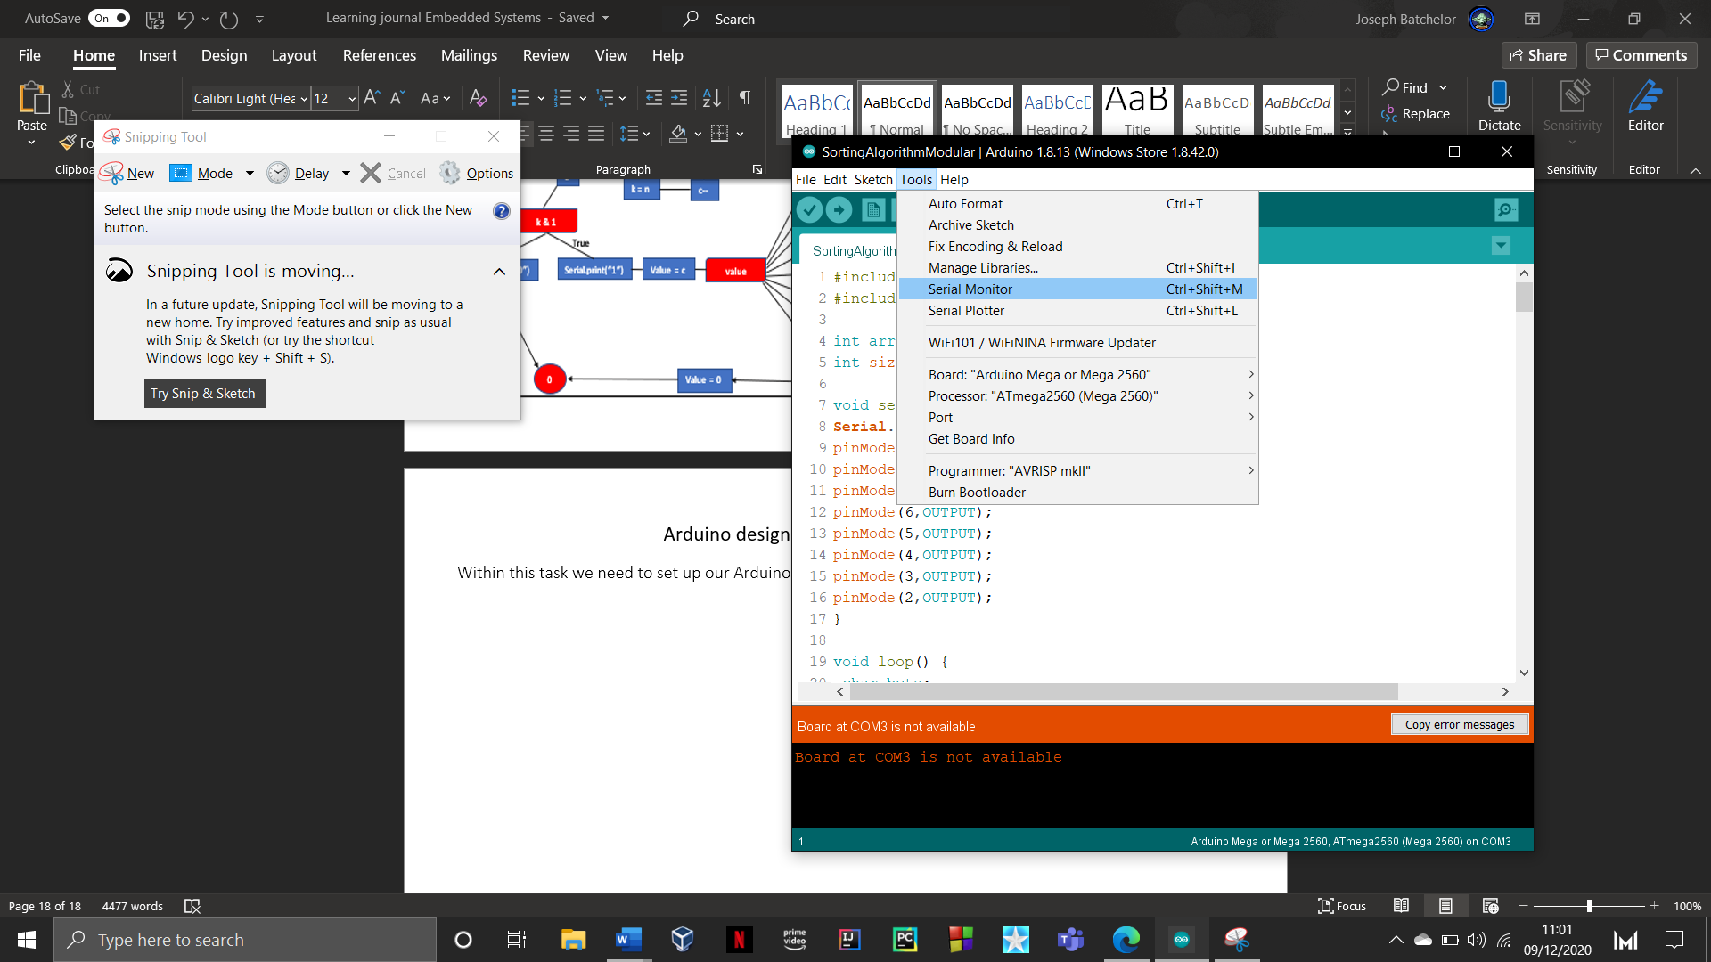Within this task we need to set up our Arduino environment to use the serial monitor.

The serial monitor is an IDE feature that acts as a terminal to send or receive information and data.

To set the serial monitor you need to navigate to the tools options and click on serial monitor.

As you can see in the image to the right you can also use the command “Ctrl + Shift + M”. Once opened a new window will be displayed.

Below is an image one what the window would like as well as how it displays information from the Arduino. When setting up our Arduino within the first task notice how the serial monitor stills uses Com 3. The Com3 port is used for communication which allows for us to display information.

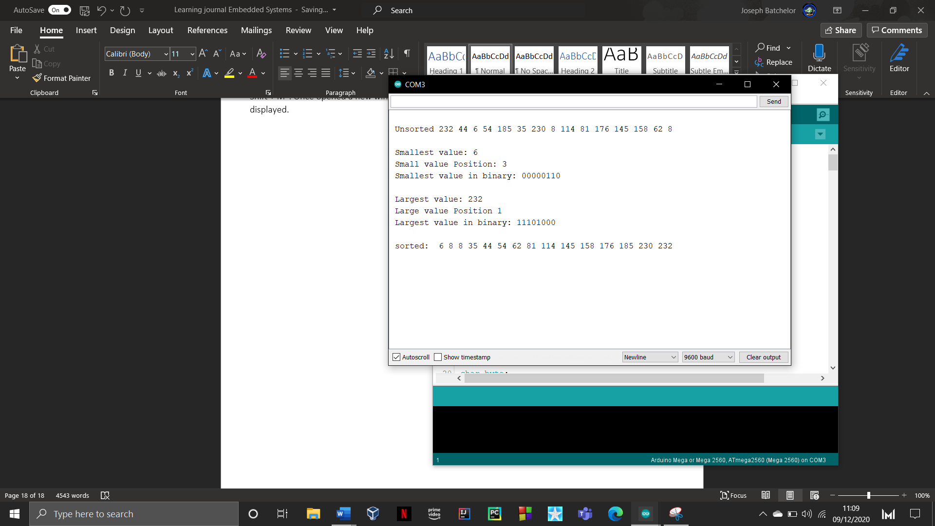Below is example of the information that is displayed when the Sorting code for task 3 is ran.

The finial highlighted area allows you to change how you would like to display your information ,as you can see I’ve set mine on a newline which will display every print statement on a new line , this can be change to others option by simply clicking on the drop down.

The next drop-down option is used to set the speed at which you wish to transfer data at. The higher the number the faster it transfers at. It is important to know that some Arduinos have a set speed which in this case the mega 2560 has a max speed of 9600 baud (baud is the unit of transmission).

The last option “clear output” will clear the terminal and remove all the printed content.

This next highlighted area is where your information and data will be printed as you can with task 3 it can print various lines of data.

This highlighted section is used for character input.

In this case for task 3 I used the input field to start the execution of code.

Simply type a letter or word and then click send.

The Arduino set up

This section is implemented to discuss the actual design and build of the Arduino. In total the build includes one Arduino mega board, one bread board, 8 LED’s of various colours and 17 pin connectors. As you can see the design is simple and straight forward.

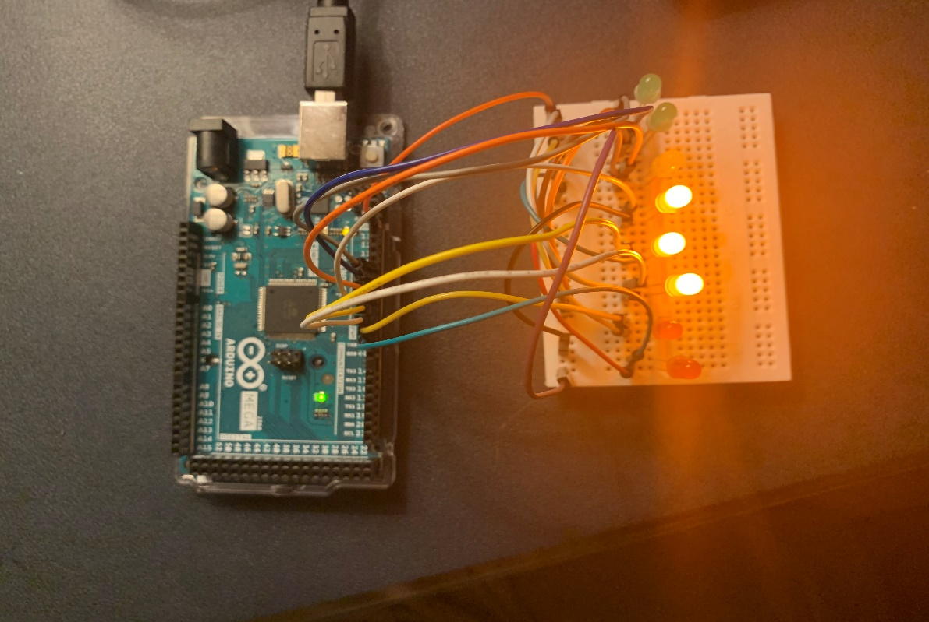As one of the requirements of the Arduino board it was tasked to be able to display the 8-bit binary value of both the smallest and largest numbers within the array. So, for example each LED will have a binary number starting with 0 and ending with 256. If the binary value was “00001” then only the first LED will be lit which should be 0.

Here are some images to demonstrate what the setup would look like.

It is a straightforward and easy setup that consist of using 8 different serial ports for each LED. I used port number 2 to 9.

The cable management became a little bit hectic however, for every LED is it needed two pin connectors, one for ground and one for the serial port.

As you can see, I have aligned 8 LED’s in in a line to simulate an 8-bit binary sequence. Starting within the right most LED this would have the value of 1 then the next would be 2 then 4,8,16,32,64 and 128 being the finale LED.

The images below show that when the values have been found they would light up the necessary LED that would make either the smallest or the largest value. For example, with the bottom right picture every value apart from the 7th binary value, which is 64, when added al together would give you the sum of the value, this this case it is 181.

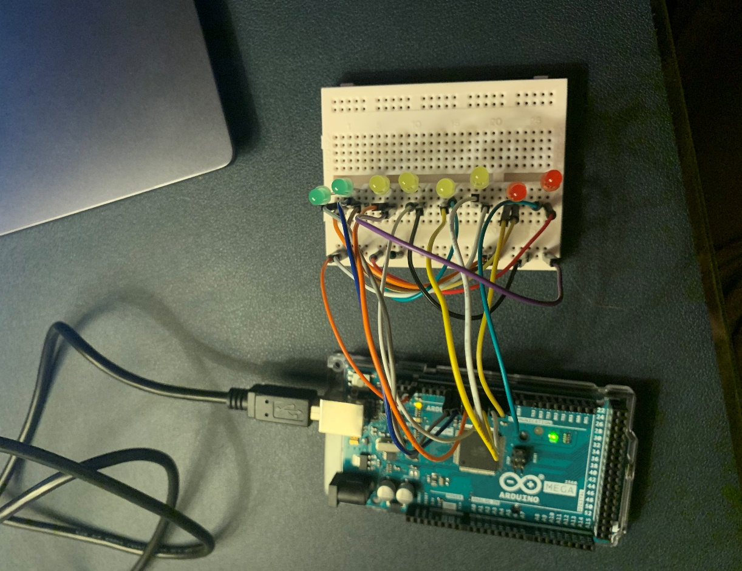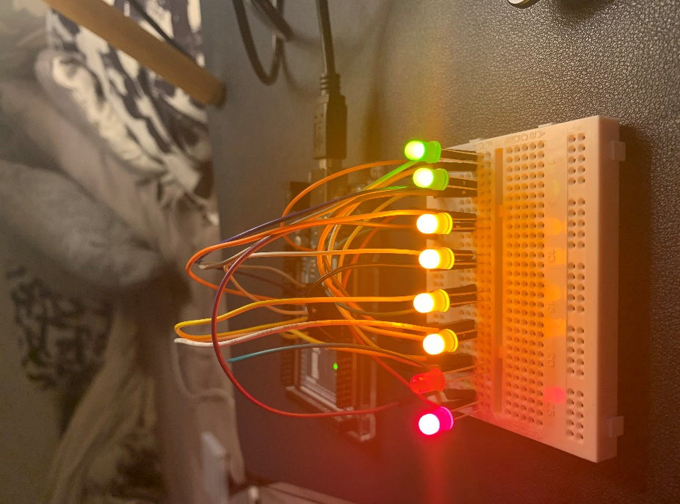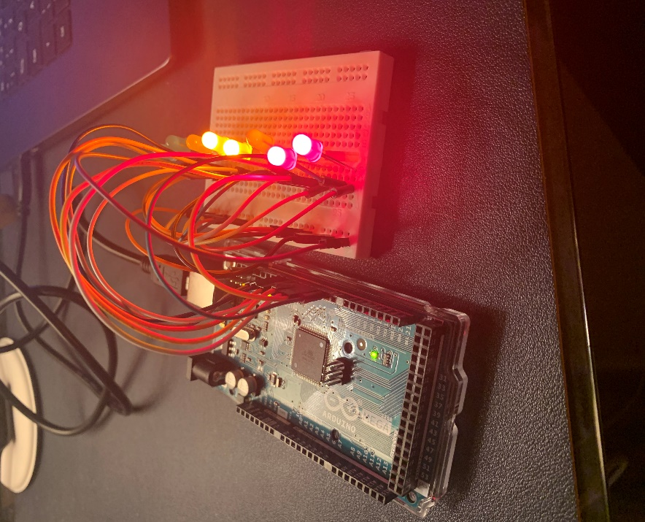

Sorting algorithm code

This section is a brief look at the structure and design of my code. This area is where I am declaring and initializing my global varibles to be used throughout my code. A global variable is one that can be called and used within different functions within my code. The two global varibles I’ve creates is an array which has been set to hold 15 elements and size which is the size of the array which is 15. The reason I have created a variable for the size is that it will help me with setting up loops throughout my code. Function setup is used to initiate communication between the Arduino board and the computer. As you can see I’ve told the Arduino board that we will be using serial ports 2 to 9 this will establish a connection.

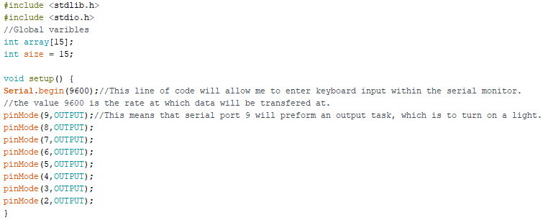

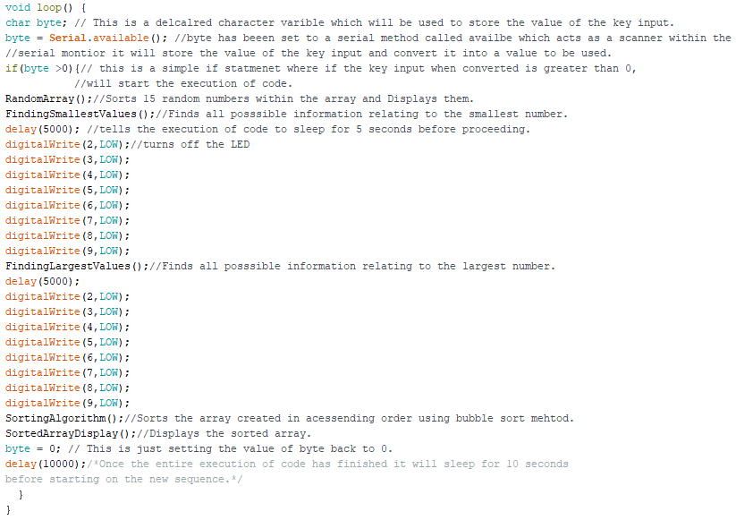

Function loop’s main purpose is to call all the functions and to continuously run them. This allows for the array elements to change providing a new sequence to be sorted, as one of the requirements of task 3, was for the sequence to change. Function loop is a feature of C that will constantly run this function forever, repeating the code nested within. In this case function loop will be used to call all my other functions and constantly run them. This will allow for the array to change its sequence meaning a new array of elements will be sorted every time.

Additionally, function loop can use keyboard input to execute the algorithm. The way this works is by setting up the serial monitor. To do this within the setup block you need to add the line of code, Serial.begin(9600). This tells the Arduino board to get ready to received information. The value simply means the speed at which it will transfer data at.

This first function is designed to store 15 random integers within the array. As one of the requirements for task 3 is to have 15 unknown values within the array. The idea is simple by using a loop I can loop through the array of null elements, every element I index with the loop ill store random. An additional task that was required was to display the array using pointers, within this function I created and used a pointer to display the unsorted sequence of values within the array. The integers must be within the range of 0 - 255. This was a simple task as this function consisted of using a for loop that would loop through the size of the array which was set to 15 elements. This means that every null element would be given a random value. Assigning a random value was done by using the line “rand () %255”. Rand () is a built-in method that generates a random number, to keep it below 255 I used %255 so that it gives you a remainder that is less than 255. Additionally, I used a pointer to display the unsorted values within the array, by using an if statement. The if statement works by displaying each value until the size has been met, which would then end the process.

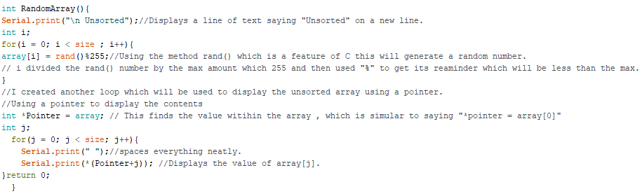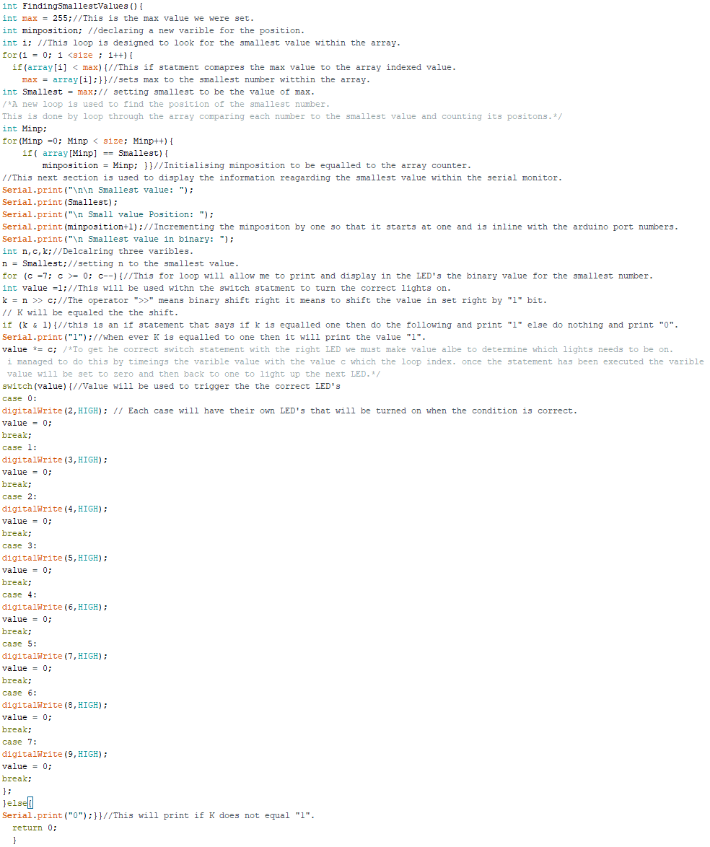

This function is designed to find the smallest value within the array. It also is tasked with finding additional information such as the position within the array and what the number is. A requirement of task 3 was to display the binary value of the both the Smallest and largest number within the array using LED’s, I also added within my code that the binary format for both values will be displayed within the serial monitor. The importance of this function was to show that I was able to display data in the serial monitor, as this tasked requires us to use the monitor as a feature. Altogether both functions use two for loops, two if statements and a switch statement. The first for loop is used to uncover the Smallest and largest value within the array.

The second part of the FindingSmallestValue function is used to display and calculate the binary format of the both the largest and smallest value. The way this is done is that both functions uses an if statement as well as a switch that contains which LED’s to switch on. By using the operator “>>” which means shift one right, I was able to print the binary value for both smallest and largest. As a requirement of task 3, we must display the 8-bit binary format of both values using the Arduino board and LED’s. My approach consisted of using a switch statement. The code will display all the information relating to both values as well as the LED’s lit for 5 seconds this done by using a delay within the function loop.



This function is the same as FindingSmallestValues (), the only difference is that some of the variables are set different or have different values. The layout and the structure are still the same as you can see below. It was easier if I did two separate functions for both the smallest and largest values because it meant I was able to separate when the data would be displayed as well as it makes it easier to display the LED’s correctly. As one of the problems was only one set would show.

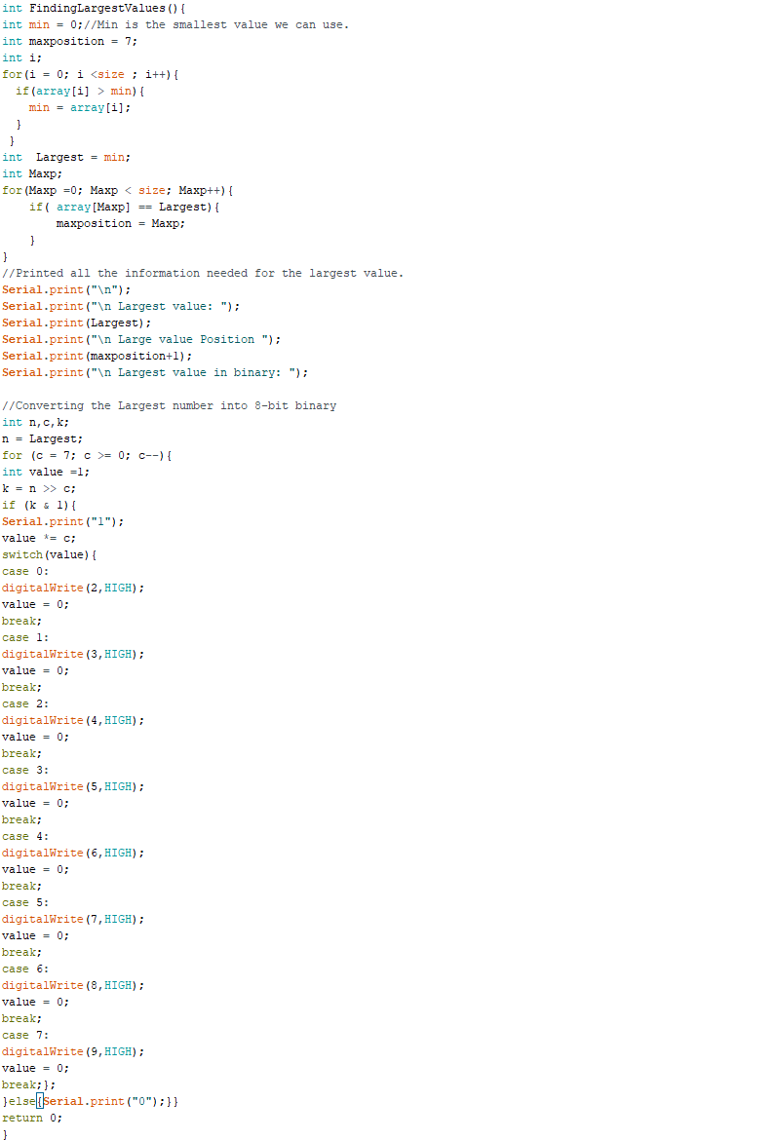

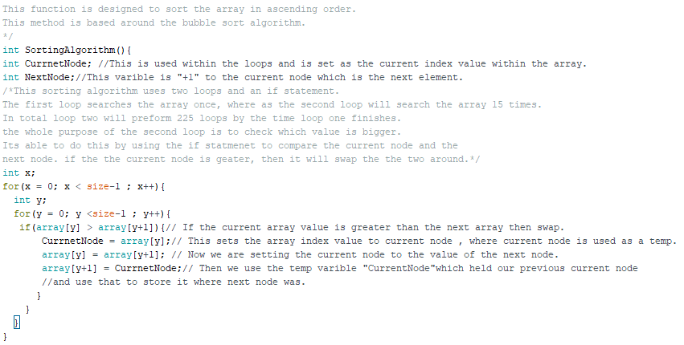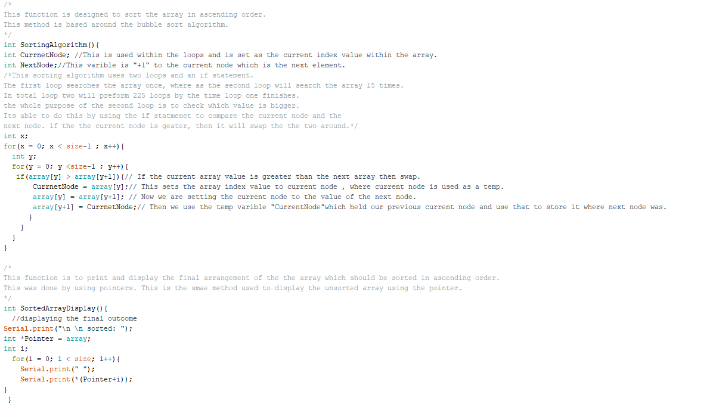

This function is designed to sort the array in ascending order. This method is based around the bubble sort algorithm. This was the main section of code that is required for task 3. Its purpose is to sort any given array so that it is in ascending order. It works by comparing values within the array and swapping them, a detailed description can be found within the comments of my code. The way this function works is by using two loops, this will allow us to swap values. Additionally, it uses an if statement that compares the current node within the loop to the next node value. If the current value is greater, then it will swap.

This can be done by saying “array[y] = array[y+1]”. This function will carry on until the first loop is completed. This should store a completed sorted array in ascending order within the array created the technique I used is based around the bubble sort algorithm. The bubble sort algorithm is a type of sorting algorithm designed for data structures.

The final function is designed to print and display the final arrangement of the array which should be sorted in ascending order. This process was done by using a pointer, this is the same method used to display the unsorted array using the pointer.

The reason we had to do this was because it was a requirement of task 3. Additionally, Pointers makes obtaining both the address as the well the index and value easier and faster than typical methods.

The task for this function is once the array has been sorted, it will display the sequence of elements in ascending order. Instead of assigning the index of the array and then displaying it we were tasked to use a pointer to display the sequence.

Setting the address of a variable can be done by using the statement “*name = &variable” the “&” will provide the address. However, if you were to remove the “&” so the statement would look like “*name = variable” this would be equalled to the first element within the array or array [0]. This is an alternative way to obtain information from an array or varibles. The advantage of using a pointer is that they can work faster with handling data.